**Burial Benefits Pre-Need Application (VA Form 40-10007)**

Table of Contents

Pre-Need Burial Benefits Application Overview 3

User Access 3

Who can access this application? 3

Navigation 3

What does it look like, and how does it start? 6

Pre-Need Burial Benefits Application 8

Preparer Information 8

Applicant Information 12

Sponsor Information 16

Sponsor Military History 23

Sponsor service period(s) 26

Burial Benefits 29

Supporting Documents 30

Review & Submit 33

Error Messaging 35

# Pre-Need Burial Benefits Application Overview

This product guide covers the Pre-Need Burial Benefits Application (40-10007)

## User Access

### Who can access this application?

Veterans, Non-Veterans, or Preparer’s for a Veteran or Non-Veteran. The user does not need to be signed into complete this application. However, if they aren’t signed in, the application will not be prefilled with their information and the users will not be able to save their application in progress. You can reference the below screenshot for more information on this:

## Navigation

**Direct url:**​ *<https://www.va.gov/burials-memorials/>*

**Or** the link for the Pre-Need application can be found on the ​**VA.gov**​ homepage.

<https://www.va.gov/burials-memorials/pre-need-eligibility/>

<https://www.va.gov/burials-and-memorials/pre-need/form-10007-apply-for-eligibility/introduction>

## What does it look like, and how does it start?

Before starting the application, users are asked to acquire the appropriate documents/digital files. We encourage users to sign in to save their form, but they can also continue without signing in.

# Pre-Need Burial Benefits Application­

## Preparer Information

First, the user will be asked to fill in general personal information. This may be in the Preparer or Applicant information section, depending on their answer to the first question (Pictured below). If they are signed in, the application will be pre-filled, but the user can also change this information. If they are not signed in, they will need to add the information. If they indicate they are “**filling it out for myself**” (See below), they will NOT see the noted screens below following this initial screen, and will go into the Applicant section.

The application will tell the user what must be filled in. If they do not enter all the required information, they will not be allowed to move on to the next page.

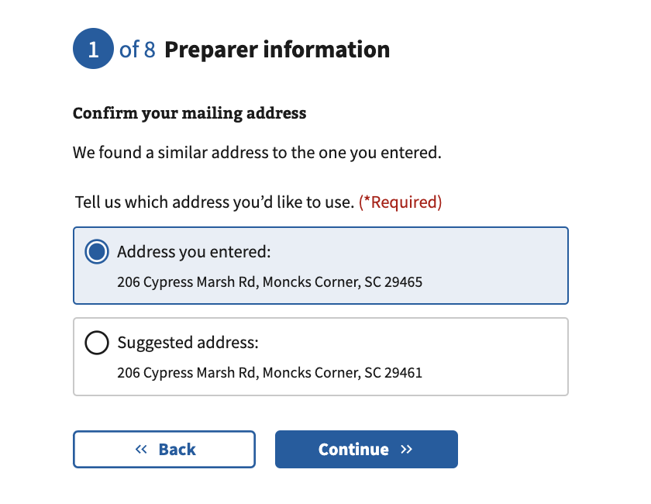

After inputting an address, the user will continue to validate their address. The user will see 1 of the 2 screens above. One will provide a suggested address that was found in the U.S. Postal System and the other screen will **not** have a suggested address but ask the user to confirm their inputted address. After selecting the address, the user will continue to the Applicant information section.

**Note**: The address validation screens will also appear in later sections, the Applicant Information and Sponsor Information.

## Applicant Information

The applicant information screens content will vary based on the user filling out the form, Veteran or Non-Veteran, and if on behalf of another individual or for themselves. The user will select their/the applicant’s relationship to the Veteran, from the list you see below. The applicant is the user applying for the burial in a VA National Cemetery under a Veteran.

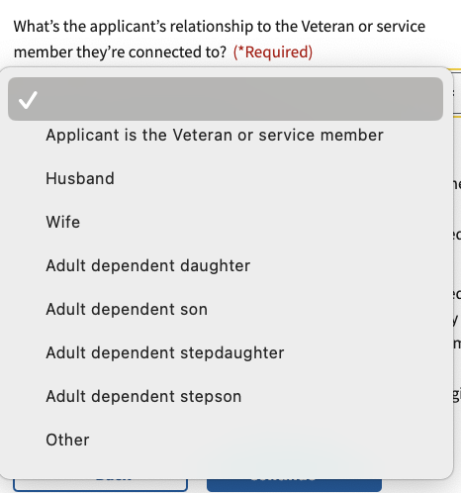

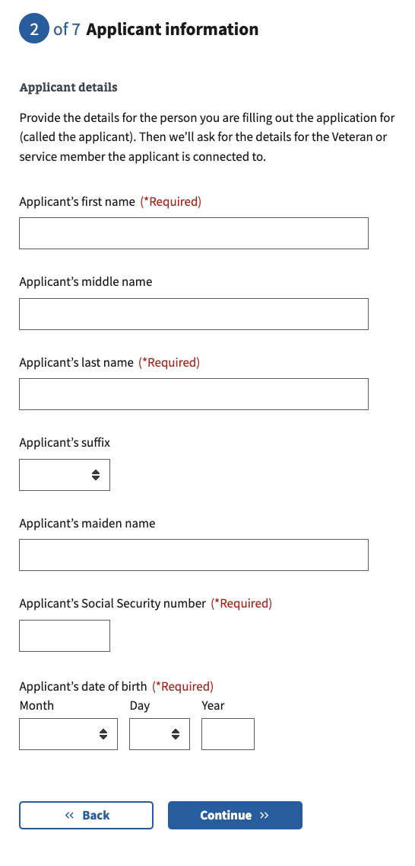

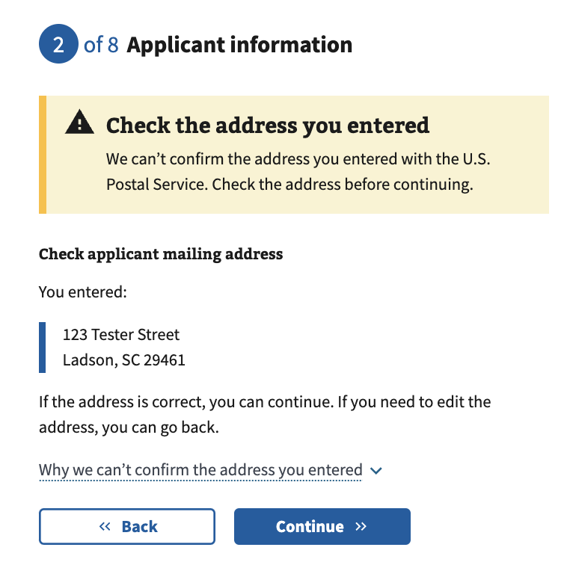

**Note**: If there is an address in the U.S. Postal System, it will provide a suggested address here, as shown in the Preparer information section above

If they select to continue, they will go to the Sponsor section. If the user is a Veteran or Preparing the application on behalf of a Veteran, the Sponsor section will **NOT** appear.

## Sponsor Information

**Note**: This section only appears for users that are Non-Veteran’s to request the Sponsor (Veteran’s) information.

**Note:** This screen only appears for an individual filling out the application on behalf of a Non-Veteran. If the user indicates “Yes”, some of their information will autofill from the Preparer Section to the Sponsor Section. They can edit any fields, if incorrect.

If the user selects “**Yes**” to the above question, they will see the next screen, where they have the option to input the date of death. If the user selects “**No**” or “**I don’t know**” they will skip the option to input the date of death.

**Note**: If the users indicated that they are the Sponsor, the death related questions will NOT appear.

If the user indicates the Sponsor has passed away, the sponsor address and contact details screen will not appear.

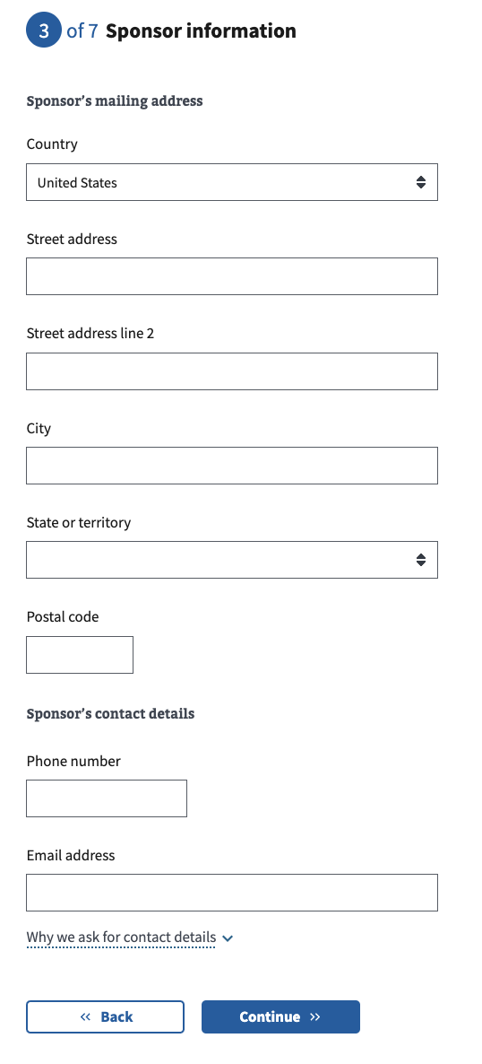

**Note**: If there is an address in the U.S. Postal System, it will provide a suggested address here, as shown in the Preparer information section above

On the next set of questions, the user will be asked about demographics of the Veteran/Sponsor.

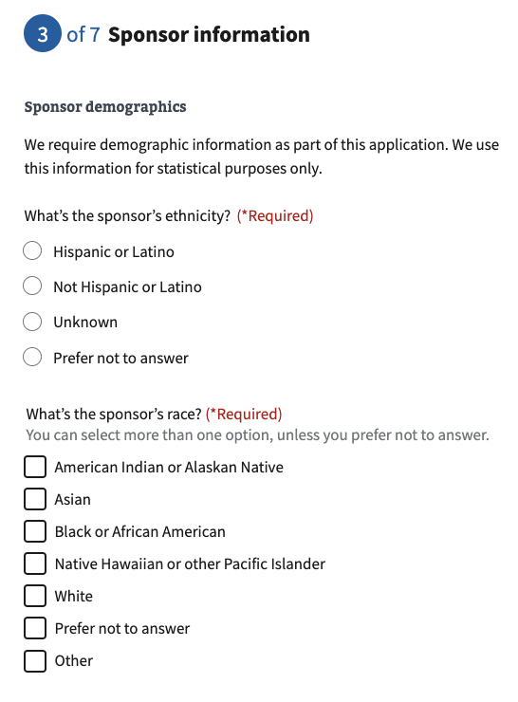

## Sponsor Military History

This section will appear for all flows but may be titled Applicant Military History, if the Veteran is completing for themselves or someone preparing the application for a Veteran is filling it out. It is to gather the Veteran’s Military History. The user will be asked to enter the Veteran’s periods of service. If they are signed in, this can be pre-filled. But they can edit and add more if they need to.

*

If the user selects “**Yes**”, they will continue to a new screen to input the previous name. If “**No**” is selected, the user will not see the next screen.

Note: This screen will not appear if the user selected “**No**” to the previous question

## Sponsor service period(s)

Next the veteran will move into the Service Period(s) section.

**Note**: The user can add up to 3 service periods. Each would display here after inputting. They are able to remove service period(s) by selecting “DELETE”.

## Burial Benefits

Next the veteran will move into the Burial Benefits section.

**Note**: If the user selects “**Yes**”, they will continue to the next screen to input the name. If the user selects “**No**” or “**I don’t know**”, they will skip the next screen, Name of deceased person

On this screen, the user is ***required*** to input the Deceased’s first and last name, if selecting “**Yes**” to the previous question.

Following their input, they will continue to the next screen.

The user has the option to input the VA national cemetery they/the applicant would prefer to be buried in. This is **not required**

## Supporting Documents

Next the user will upload any supporting documents they have. You can expand by clicking the **“+”** to see what kind of files you may upload. You are also able to mail or fax supporting files and that information is provided below, “**Can I mail or fax files?**”.

Once a document is uploaded, the application prompts the user to indicate what type of document it is, it is ***required***:

## Review & Submit

The last step is the review application page. Here the user can review the information they’ve entered by clicking on the (**+**) plus signs next to each section. If the user clicks on the (**+**) plus sign, the section will open and show what the user entered for each field for them to review. If something looks wrong, the user can select the “**Edit**” button and will be able to make edits on the information, then “**Update**” to save changes.

**Note**: This screen and some sections will change based on who is completing this application. (Veteran, Non-Veteran, or an Individual Preparing the application on the Veteran or Non-Veterans behalf)

Once the user has reviewed the information and made any changes, they can select to submit the application. They can only successfully submit the application after selecting the “I have read and accept the privacy policy” check box. After selecting “**Submit application**” the user will be shown the below page which contains a summary of the information, as well as additional information links that can help the veteran understand the process for their education claim:

### Error Messaging

***Required Response***

***Not Valid***

***Selecting options that aren’t valid together***

***Supporting Document file is wrong format***

***Submission Failure***